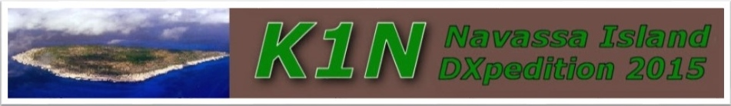

Dear members of the National Capital DX Association,

Recently, the KP1-5 Project announced plans to activate the #1 most-need DXCC entity - Navassa Island (KP1). This is the same group that conducted the highly successful DXpedition to Desecheo Island (K5D) in 2009. This operation is scheduled for 14 days and will occur in late January, 2015. The DXpedition leaders, Bob Allphin, K4UEE and Dr. Glenn Johnson, W0GJ, have assembled a terrific team of great operators with many years of DXpedition experience. They are: Lou – N2TU; Ralph – K0IR; Jeff – NM1Y; Gregg – W6IZT; Mike – N6MZ; George – N4GRN; Tim – K5AC; Tomi – KT4TTT (HA7RY); Jerry – WB9Z; Bob – N2OO; Mike – NA5U; Craig – K9CT; George – AA7JV. Included are four members of the CQ DX Hall of Fame: W0GJ, K0IR, N2OO and K4UEE.

The last major operation from Navassa Island was 1993…a generation ago! Since then, Navassa Island has climbed steadily back to the very top of the most wanted list. Our goal is to give everyone who needs a contact for an all-time new one (ATNO) at least one QSO. Secondarily, we will provide band/mode contacts for those chasing the DXCC Challenge and other awards.

The team will be QRV 24/7 on 160m-6m CW, SSB, and RTTY modes. The operation will be based around the lighthouse area on the island. We plan eight stations….all using Elecraft K3's, a full complement of antennas, and 500 watt amplifiers.

As with all DXpeditions to "Top Ten" DXCC entities, this is a costly venture. The expenses total just over $300,000 - due to the necessity of using helicopters. Each operator must contribute a minimum of $7,500 plus personal expenses by paying their own way to/from the helicopter departure point. They will be away from work, home and family for three weeks and are all prepared for the financial and physical risks inherent in a major DXpedition of this magnitude.
The DXpedition team has committed to pay 50% of the total costs. The KP1-5 Project needs the support of the worldwide DX Community to pay the other half of the costs. We believe this is a fair arrangement for the team and DXers alike.

INDEXA has made an extremely generous contribution to the project and was first to offer support. Now, other DX Clubs have offered support as well but we need broad participation on the part of DX Clubs worldwide. We also need the help of individual DXers, not only from North America, but also from Europe, Asia, Africa, South America, and Oceania.
Since the DXpeditions is planned for January 2015, time is quite short to raise the necessary funds.
So, please consider a generous contribution to this project. To have your club or organization’s logo included with the QSL card please contribute $500 or more; or $250 to have your club’s name included with the QSL card. Individual contributions of $100 or more will be listed with the QSL card. Everyone who supports the DXpedition will be listed and properly recognized on our website.

We encourage you to visit the Navassa Island website (www.navassadx.com) and donate via the PayPal link. It’s free and easy. Or you can contribute with a major credit card, even without a PayPal account. If that is not convenient, you may make a check or money order payable to The KP1-5 Project and mail to Mike Thomas NA5U at to the address shown below. Remember to put your clubs name on the “for" line.

Please mail all contributions to:
The KP1-5 Project
C/o Mike Thomas, NA5U
5717 Puerto Vallarta Dr.
North Richland Hills, TX 76180

