Saint Helena ZD7 Dxpedition Proposal

Background - St. Helena Island ZD7, lies about 1,200 miles (1,950 km) west of the southwestern coast of Africa. It has a maximum length (southwest-northeast) of 10.5 miles (17 km) and a maximum breadth of 6.5 miles (10 km).
This location is of volcanic origin, but volcanic activity on the island is now extinct. Perpendicular cliffs rise 1,600 to 2,300 feet (490 to 700 metres) on the eastern, northern, and western sides of the island. The island’s two highest points are Diana Peak (2,690 feet) and Mount Actaeon (2,625 feet). South of the mountains, water-cut gorges are dispersed, becoming deep valleys near the sea. St. Helena lies in the path of cool South Atlantic trade winds, and its climate is temperate, with warm summers and only slightly cooler winters.
Is St. Helena Island Needed: According to the DXCC Most-Wanted List for June 2023 presented by Club Log, this entity is most needed by the world’s dx community on the low bands, especially 3.5 and 1.8 MHz. Overall, ZD7 is listed as most needed entity #53 on 1.8 MHz and #36 on 3.5 MHz. Although the other bands are not as needed, the overall concept of this operation is to produce as many contacts on the low bands as possible.
Best time to operate: The best time to accomplish the overall goal of working as many stations as possible on the low bands would be during the North American, European, and Japanese winter. According to VOACAP, this would best be accomplished sometime in the February and March time frame We are now in Solar Cycle 25 with peak sunspot activity expected in 2025. My recommendation would be to travel in the February – March 2025 time period.
How long should this dxpedition run: Flights into and out of St. Helena Island run once a week (usually on Saturday and/or Sunday). During peak season (summer) flight schedules increase to 2X per week (Saturday and Tuesday). Based on flights into and out of St. Helena Island, and the prep/tear down time, I believe we want to be able to be on the air making contacts for a minimum of 10 days/nights. We should be able to fly in, set up, operate 10 days, tear down and be off the island within 2 weeks.

Venue: Our operating location is being provided by amateur Radio Operator Mr. Barrie Williams, ZD7MY, who has graciously offered to vacate his QTH and allow us the run of his home and property. Mr. Williams shared with me that he and his XYL would stay with in-laws. Mr. Williams has offered his QTH for a period of 2 weeks. Mr. Williams has a 3 bedroom house and can accommodate 4 people. His property at the moment has a 6M5X 6 meter beam and a very dilapidated Cushcraft R-9. I have just recently sent Mr. Williams a Cushcraft MA160-V vertical (160 meter antenna) along with 24 radials and radial plate. I own a MA160-V and am familiar with its capabilities. That antenna (with an antenna tuner) Works well on 5.0Mhz, 7.0Mhz, 10.1Mhz 14.0MHz. It does not work on 3.5MHz. Commercial power on St. Helena is 220V/50Cycle service. The type of outlets are G type, therefore, no backup generator is needed. 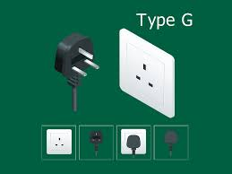

The photo below was provided by Mr. Williams and shows a view from his QTH.

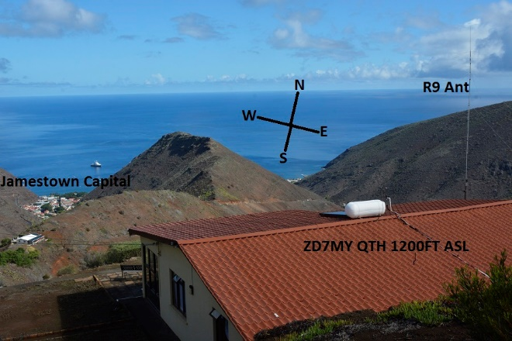

Planned radio operations: Mr. Williams radio equipment consists of 2 transceivers. He has a Yaesu 991 and I just sent him a Yaesu FTDX10. Additonally, Mr. Williams has an amplifier, the ACOM 600S. So we have not discussed the size of the go team and therefore I would be guessing as to what equipment we need. Let’s say for now, we plan on running 2 transceivers. At minimum, we would need to bring at least 1 antenna if not 2, probably a vertical and also a fiberglass push up pole for an inverted vee. Also, we most likely would need a 2nd amplifier. Once we have a better idea of the team, a committee would than sort out the details of a go list and compare it to what is already there.
Personal Cost: I performed an analysis of the basic travel cost and requirements of the Government of St. Helena. The following are the entry requirement for that country:
- Evidence of a return ticket
- $225,000 for travelers’ medical insurance to include medical evacuation insurance
- Adequate Accommodations
- Sufficient funds for the stay
- Entry fee of 20 british pounds (can be paid with dollars)
Getting to St. Helena is fairly straight forward. One would fly from the USA to Johannesburg, South Africa. Mostly likely make accommodations at a hotel by the airport until the weekend flight goes to St. Helena.
I did a mock up of travel and here is what I found:
- United Airlines Economy ticket (fully refundable) round trip to Johannesburg: $3100
- Holiday inn near Johannesburg airport runs between $60-100 per night
- Airlink Airways: Johannesburg to St. Helena: $450.00 economy seat
- Medical travelers insurance with medical evacuation runs between $500-700 dollars depending on your coverage
That total comes to around $4,800.
In the event we were to bring equipment, the airline charges $200 dollars for oversized bags and $200 dollars for each extra bag.
Getting Donations: There are a couple of ways to get donations. One way is to put up a web page that has a donation link to a paypal account. We can discuss further. Another way is to have a committee go on an email campaign to all of the DX clubs asking for donations. Of course, we would have a clublog account and we would ask for an amount of green stamps for QSLs. From what I’ve seen recently, the going rate is averaging 3 dollars per request. So if your running 2 transmitters 24 hours a day for 10 days at a QSO rate of 60 per hour, that comes to about 1500 per transmitter per day. So lets say 3000 per day times 10 days which comes to 30K QSO’s. out of those maybe 15K of them are unique operators. So out of the 15K let’s say 8 thousand of them ask for a QSL. That would net us 24 thousand dollars on the back end, which I think is a realistic number.

So Phil, that is a rough idea of where we are. In the event we move forward, it would probably be a good idea to find out how many people (who are not going) in the club who would be interested in helping out by participating on a subcommittee.
We could use someone who understands computers to set up a web page.
We need someone who has a 501 3c account to handle funding. This person would serve as the treasurer of the project.
We need a liaison who would coordinate communications with both Mr. Williams and the press for all updates and releases.
We need someone to make purchases for equipment we need.
We probably should have someone pre build any antenna so we don’t have to do it on site.
I am available to chat with you on zoom anytime. I have no plans except to operate in field day. So send me your availability and I’ll be there.
Kindest Regards,
Art WA7NB

